**SQL Server + Power BI Portfolio Project Document**

**Title: Toman Bike Share Performance Dashboard**

**Introduction**

As a Data Analyst for Toman Bike Share, the primary focus of this project is to assess the feasibility of increasing prices for the upcoming year. Utilizing a comprehensive dataset provided by the company, this project involves building a database, developing SQL queries to extract and analyze key data, and creating an interactive Power BI dashboard. The aim is to provide a data-driven basis for pricing decisions, ensuring that the company's strategy aligns with market conditions and customer behavior.

**Objective**

The objective of this project is to analyze Toman Bike Share's data to determine whether an increase in pricing for the next year is viable. The analysis will explore current pricing structures, customer demographics, ride patterns, and revenue data. By identifying trends and patterns, the project seeks to provide actionable recommendations for pricing adjustments that maximize revenue without negatively impacting customer satisfaction and usage.

**Project Overview**

This project focuses on developing an interactive dashboard for "Toman Bike Share" to visualize key performance metrics. The dashboard will facilitate informed decision-making by providing insights into hourly revenue, profit trends, seasonal revenue, and rider demographics. The data is sourced from a SQL Server database and analyzed using Power BI.

**Data Preparation and Development Steps**

1. **Create Database:**
   * **Database Name:** Toman_Bike_Share
   * The database is created to store all relevant data for Toman Bike Share.
2. **Checking for Duplicates:**
   * Duplicates were checked and handled in the tables bike_share_yr_0 and bike_share_yr_1 to ensure data quality.
3. **Union of Tables:**
   * The two tables (bike_share_yr_0 and bike_share_yr_1) were combined using a UNION operation to consolidate the data.
4. **Creation of Temporary Table:**
   * **Temporary Table Name:** BikeDataset1
   * This table includes selected columns: dteday, Season, a.yr, hr, weekday, rider_type, riders, and calculated columns:
     + Revenue: riders * price
     + Profit: riders * price - COGS * riders
5. **View Creation:**
   * **View Name:** view_BikeData
   * A view was created based on the temporary table BikeDataset1 to facilitate easier access and data analysis in Power BI.

**Refer:** SQL Code for SQL query.

**Power BI Dashboard Development**

**Measure:** Profit Margin = (SUM[Revenue] – SUM[Profit])/(SUM[Profit])

1. **Connecting to SQL Server:**
   * The view table view_BikeData was imported from the SQL Server database into Power BI for further analysis and visualization.
2. **Dashboard Components:**
   * **Card Visuals:**
     + Displays total Revenue and Profits as key metrics.
   * **KPI Over Time:**
     + A line and clustered column chart visualizing the trends in key performance indicators over time.
   * **Pie Chart for Rider Demographic:**
     + Visualizes the distribution of riders by demographic categories (e.g., age, gender).
   * **Bar Chart for Revenue by Season:**
     + Shows the revenue generated in each season, highlighting seasonal trends in bike share usage.
   * **Matrix for Hour vs. Weekday Revenue:**
     + A matrix visualization that breaks down revenue by hour and weekday, providing insights into peak usage times.
   * **Slicer for Year:**
     + An interactive slicer allowing users to filter data by year for comparative analysis.
   * **Additional Card Visuals:**
     + Riders (in millions) and percentage of profit margin.

**Data Outcome Summary**

* **Revenue by Season:**
  + The analysis indicates that **Season 3** consistently generated the highest revenue in 2021 and 2022, compared to other seasons. This insight can guide marketing and operational decisions, such as optimizing resources during peak periods.

**Recommendations**

1. **Conservative Increase:**
   * Consider a conservative increase in pricing or capacity during peak seasons to maximize revenue without overwhelming resources.
   * Considering the substantial increase last year, a more conservative increase might be prudent to avoid hitting a price ceiling where demand starts to drop. An increase in the range of 10-15% could test the market’s response without risking a significant loss of customers.
2. **Price Setting:**
   * Implement a segmented pricing strategy that reflects the demand and rider demographics, potentially offering discounts during off-peak hours or to specific rider categories.
   * If the price in 2022 was $4.99, a 10% increase would make the new price about $5.49.
   * A 15% increase would set the price at approximately $5.74.
3. **Recommended Strategy:**
   * **Market Analysis:**
     + Conduct a thorough market analysis to understand competitive pricing and service offerings.
     + Conduct further market research to understand customer satisfaction, potential competitive changes, and the overall economic environment. This can guide weather learning towards the lower or higher end of the suggested increase.
   * **Segmented Pricing Strategy:**
     + Tailor pricing based on rider segments and usage patterns, ensuring that pricing is competitive yet profitable.
     + Consider different pricing for casual versus registered users, as they may have different price sensitivities.
   * **Monitor and Adjust:**
     + Continuously monitor revenue and profit metrics, adjusting strategies in response to market conditions and rider feedback.
     + Implement the new prices but be ready to adjust based on immediate customer feedback and sales data. Monitoring closely will allow you to find-tune your pricing strategy without committing fully to a price that might turn out to be too high.

**Analysis**

**Evaluate whether we can raise the prices for the upcoming years which was our central question**

We can see that we raise the price by a dollar and then we saw that gigantic increase in profit and gigantic increase in Riders.

If our riders were able to sustain a pretty sizable increase in our price also increase in Rider’s year on year that pretty good and profit also there is no change so let's get into some analysis calculation.

Calculate our change in Price

4.99 – 3.99 = 1 /3.99 = 0.25. So, 25% increase in price and also, we saw a gigantic jump in our Revenue.

Demand of the riders as our profit

2049576 – 1243103 = 806473 / 1243103 = 0.64. So, 64% increase in rider’s count.

Obviously, if we increase the price by 25% and we still saw the increase of 64% we can feel with a pretty high degree of confidence that if we increase the price a little bit more and it should not affect demand now that assuming everything works in a linear way and there is a metric the people use used to kind of usually understand that prices in something called elasticity.

0.65/0.25 = 2.6/0.25=10.4

64/25=2.56

2.56 price elasticity can tolerate an increase usually this number is negative saying that if we increase the price that demand will go down by 2.56 but however in our case it goes up so there are obviously other things that play but it's pretty clear we can increase the price very conservatively.

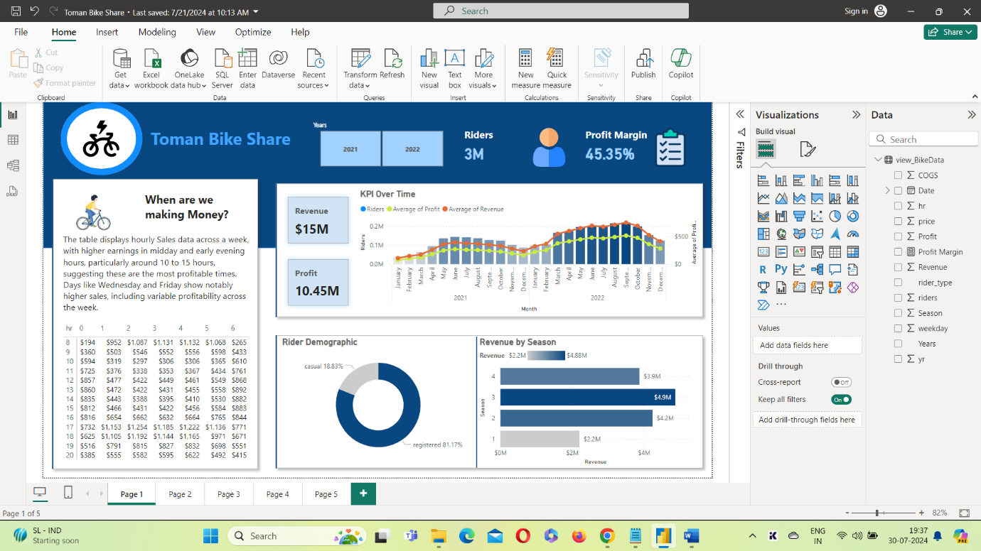

**Conclusion**

The Toman Bike Share Performance Dashboard provides a comprehensive view of the company's financial and operational metrics. By leveraging data from the SQL Server database and visualizing it in Power BI, the project enables Toman Bike Share to make data-driven decisions to enhance profitability and optimize operations. The recommendations provided aim to capitalize on identified trends and improve overall business performance.

**Reflection**

This project underscored the importance of thorough data preparation and analysis in making informed business decisions. The integration of SQL and Power BI proved effective in not only managing and analyzing large datasets but also in presenting complex data in an accessible and actionable format. The insights gained from this analysis will be instrumental in guiding Toman Bike Share's pricing strategy. Going forward, continued refinement of data models and the inclusion of additional variables will enhance the accuracy and utility of the analysis.